

Advanced Data Structures & Algorithms

Software Year 3

CA3

Project Report

Gábor Major

C00271548

13th December 2023

**Contents**

Introduction 2

Part 1: Heap Application 3

Section 1: Description of the Application 3

Section 2: Data Structures Used 3

Section 3: Pseudocode of operations: 3

Section 4: Demo using example 4

Part 2: General Tree Application 5

Section 1: Description of the Application 5

Section 2: Data Structures Used 5

Section 3: Pseudocode of operations: 5

Section 4: Demo using example 6

Part 3: 7

Section 5: Description of methods used 7

Section 6: Test data Used 7

Section 7: Sample execution 7

Section 8: Copy of Code 7

Section 9: Conclusion 10

References 11

# Introduction

This report was commissioned by Áine Byrne, lecturer Advanced Data Structures & Algorithms as submission for assessment for this module.

This report is for creating an implementation for a Heap Application and for a General Tree Application, and is split into the following 3 parts.

1. Implementation of the Heap Application, with a description, data structures, pseudocode, and demo example.
2. Implementation of the General Tree Application, with a description, data structures, pseudocode, and demo example.
3. Python code implementation for the Heap Application, containing a list of functions used in the code, all test data used, execution examples, and a full copy of the code.

Finally there is a conclusion at the end of the report about the success of the assignment.

# Part 1: Heap Application

## Section 1: Description of the Application

The heap is a data structure that is used to hold values in two ways, in a min heap or in a max heap. Each node of the heap has two children which are either both smaller or bigger depending on the type of graph.  
In this application a max heap will be used where the biggest value in the heap is at the root, and each nodes’ children are smaller than its value.

## Section 2: Data Structures Used

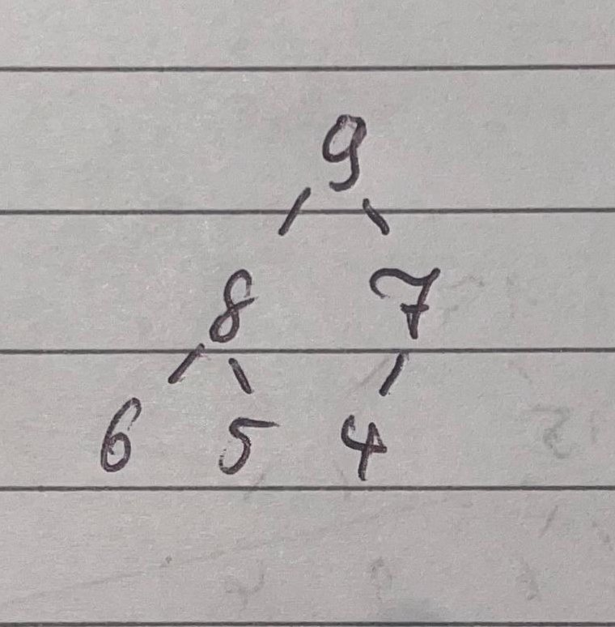To store the heap a simple array will be used. It stores all the values of the nodes in the array. The first value of the array is always 0 as this is not used.   
Parent children relationship is gotten through multiplying the index of the parent by 2 to get the left child, and for the left child add one onto the left child index. To get a parent index of a child you do the operations in reverse.

Example:

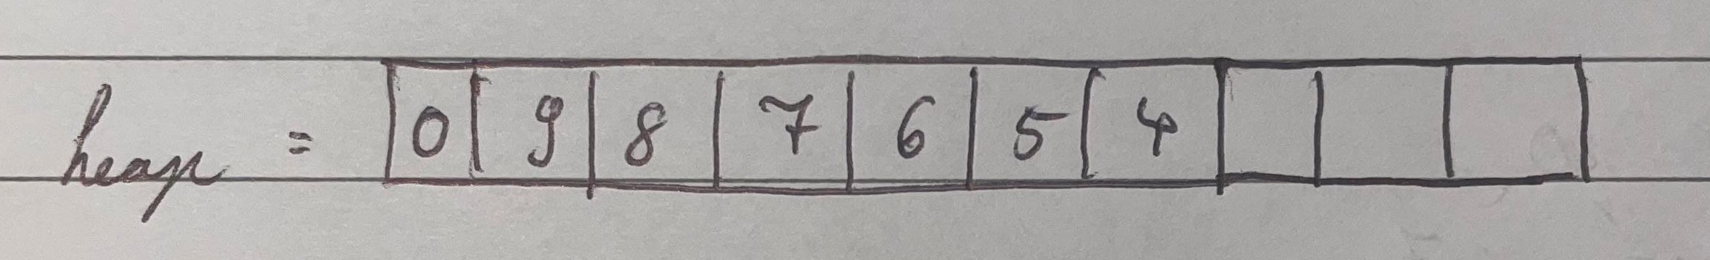

The one helper variable that is used is called last_index. It is an integer which stores the location of the last spot in the array that has a value in it.

Example, for the above heap:

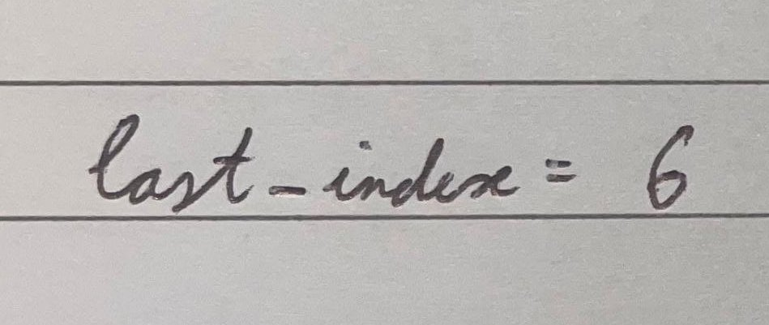

## Section 3: Pseudocode of operations:

The function upHeap is assumed to be known, and the size of the array is also assumed to be able to hold all of the data.

Pseudocode of each of the methods used

Insert (x): adds a number x unto the heap

last_index++;

heap[last_index] = x;

upHeap(last_index);

FindParent(x) : returns the parent of node stored at position x

return x // 2;

FindChild(x): returns the children of a node stored at position x

return [x * 2, (x * 2) + 1];

DeleteSmall() : deletes the smallest value stored in the Max heap

starting_index = find_parent(last_index) + 1;

smallest_value = heap[starting_index];

smallest_value_index = starting_index;

for (int i = starting_index + 1; i < last_index + 1; i++):

if (heap[i] < smallest_value):

smallest_value = heap[i]

smallest_value_index = i

temp = heap[smallest_value_index];

heap[smallest_value_index] = heap[last_index];

heap[last_index] = temp;

heap[last_index] = 0;

last_index--;

upHeap(smallest_value_index);

## Section 4: Demo using example

Using the example given above for the heap, and last_index the four operations are demoed.

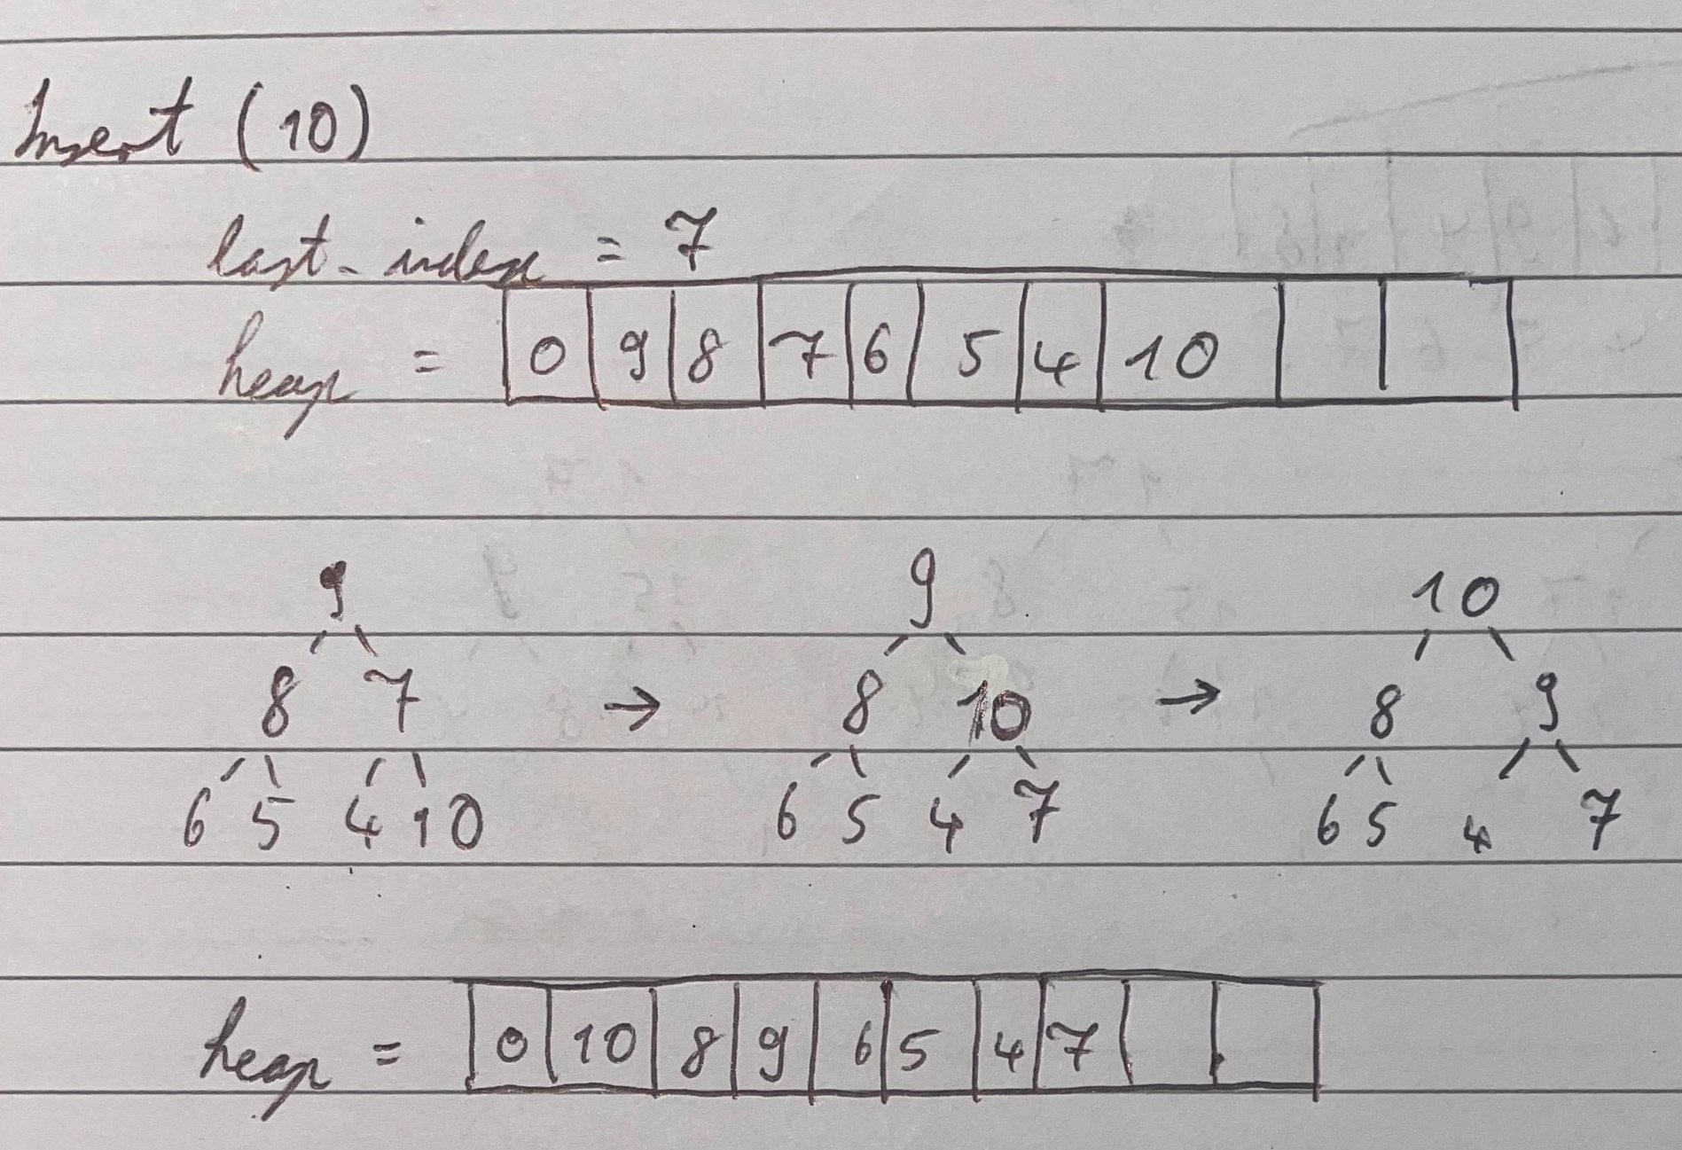Insert(x)

last_index is incremented and new value is put into the last place

FindParent(x)

The index given is floor divided by 2.

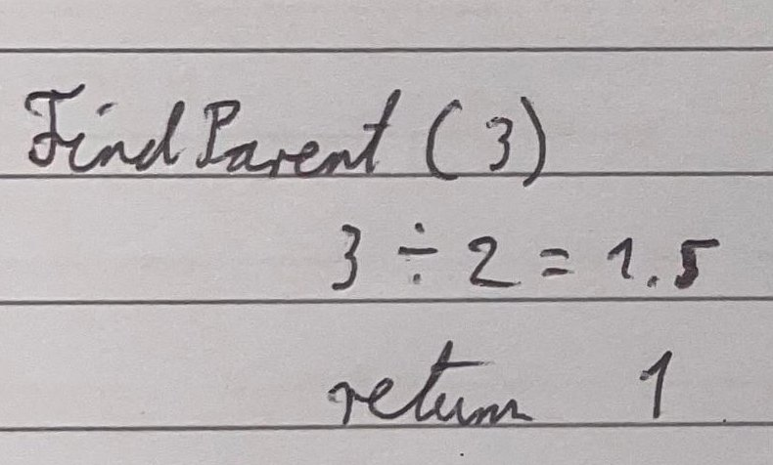

FindChild(x)

The index given is multiplied by 2 to get the left child, and one is added to that to get the right child.

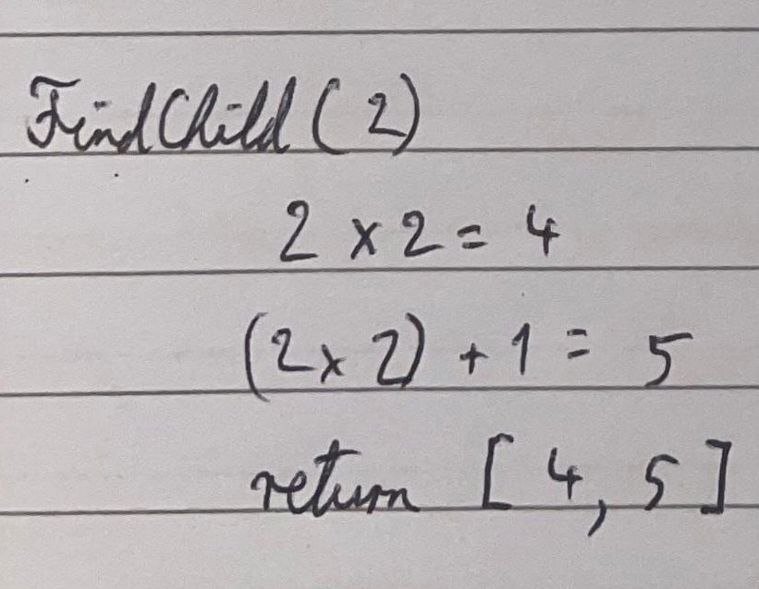

DeleteSmall()

First the smallest value is fo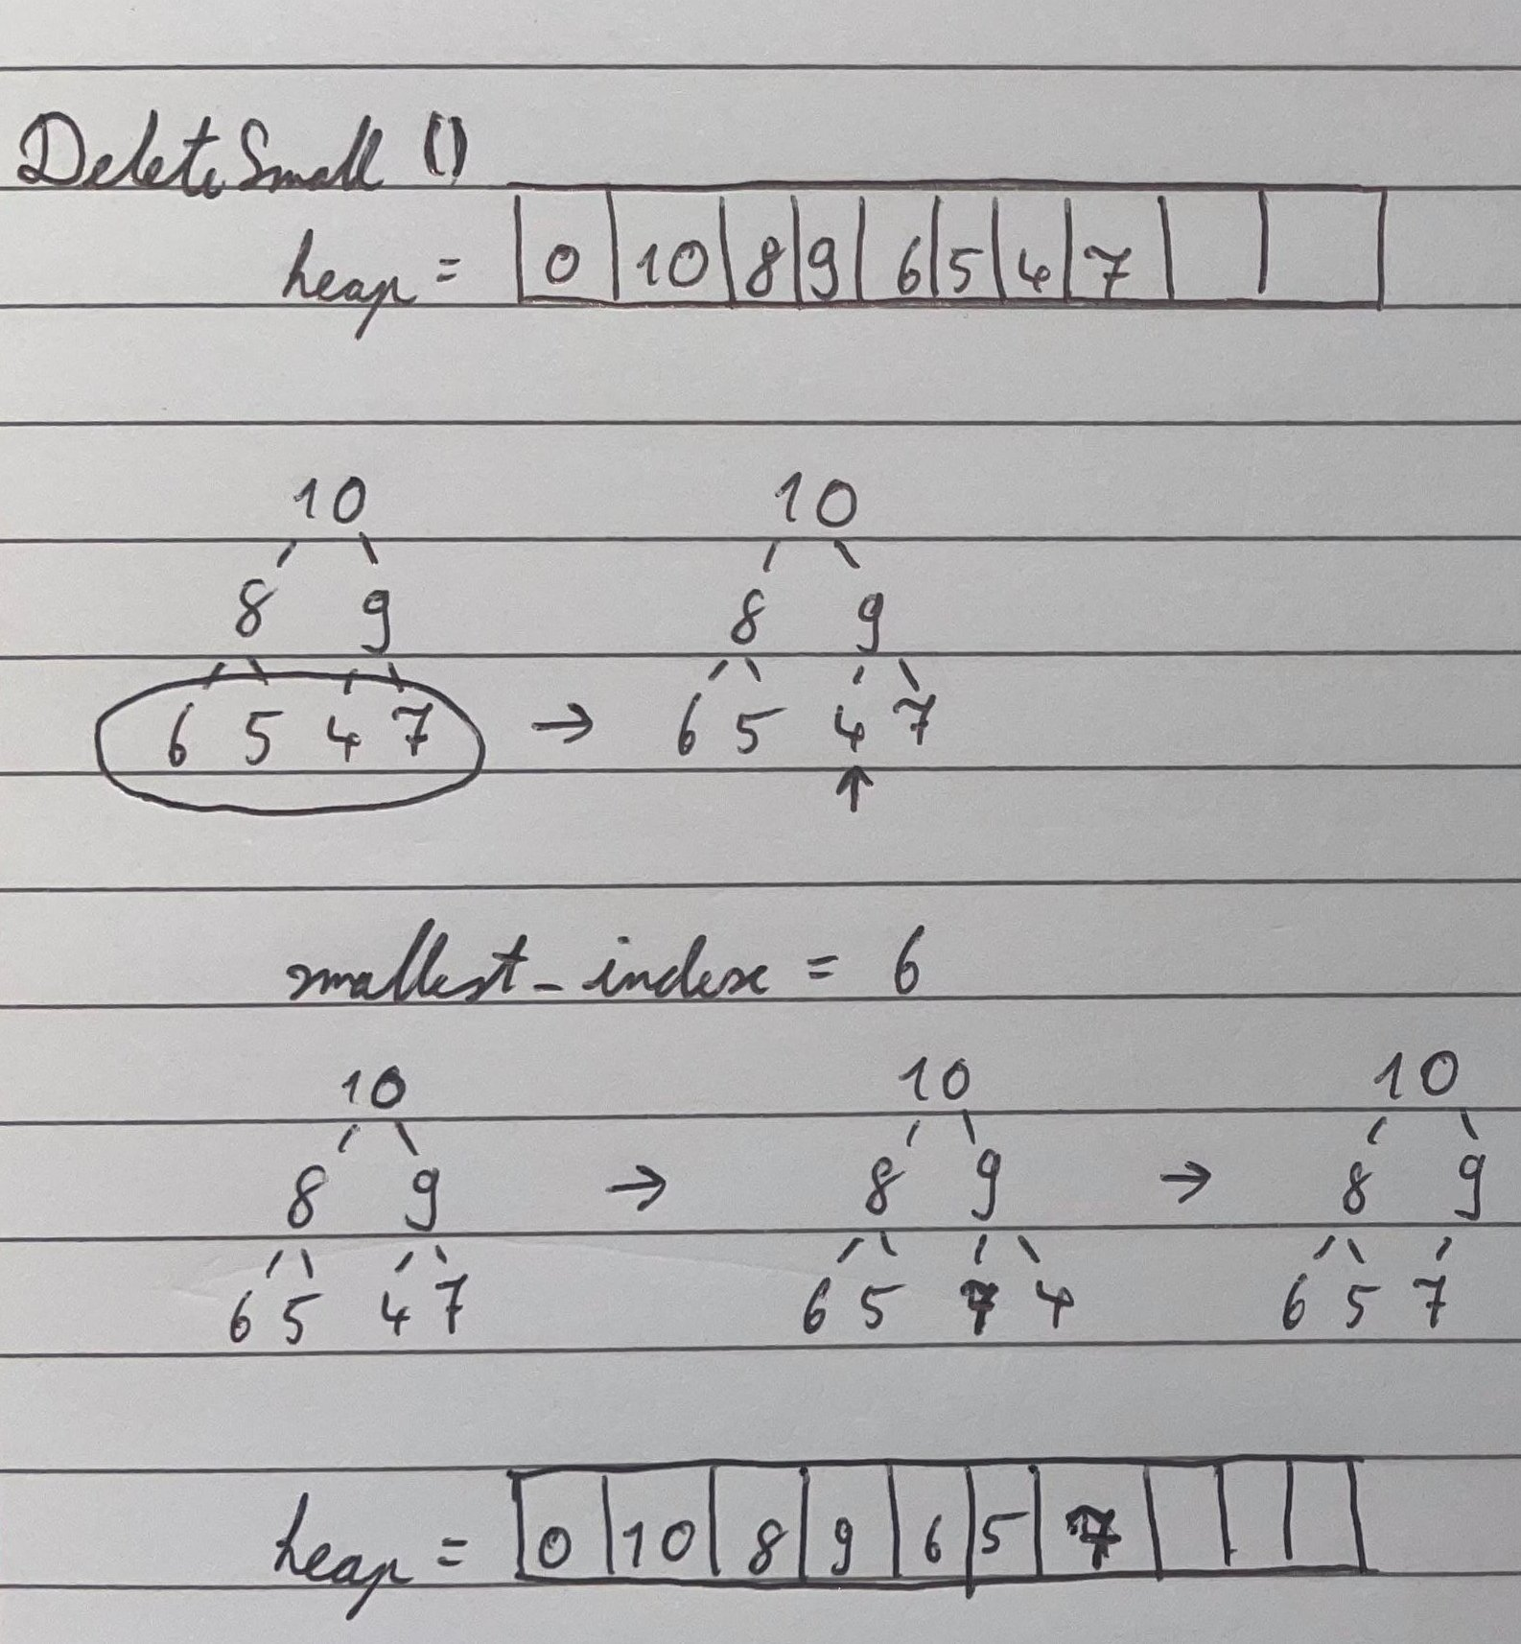und, searching only through the leaf nodes. It is then swapped with the last node, and deleted. Finally the swapped node is up heaped through the heap.

# Part 2: General Tree Application

## Section 1: Description of the Application

The general tree is a data structure that stores data in a sequential manner with variations like all of the moves in a game of noughts and crosses.

## Section 2: Data Structures Used

There are many different ways to store a general tree but this application stores it using a left child, right sibling style.  
Each node contains a value, a left child pointer, a parent pointer, and a right sibling pointer.

Example:

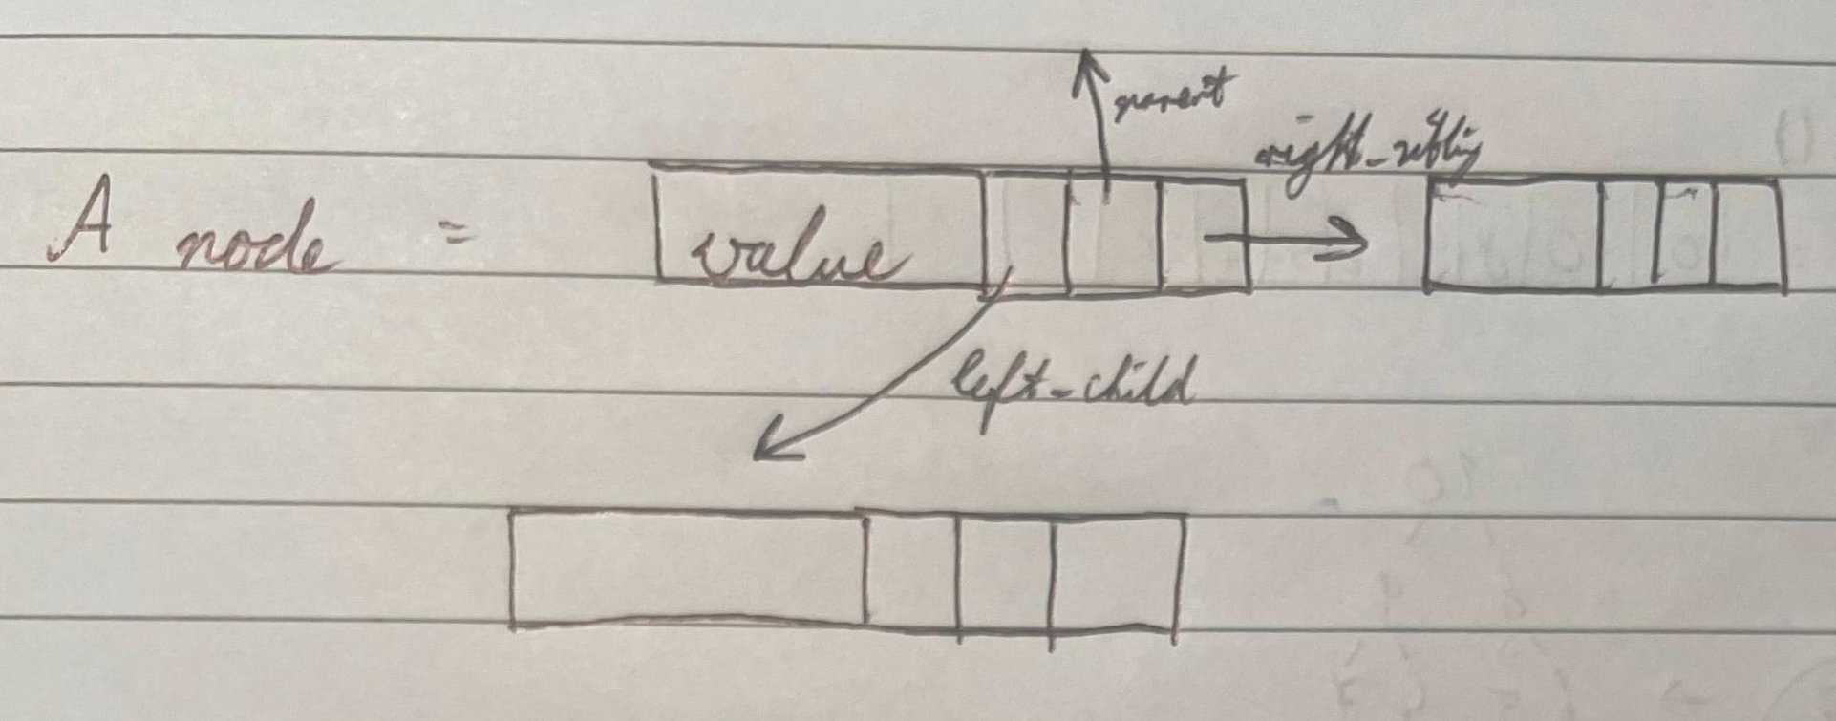

A root pointer is available to not lose the General Tree itself.

Example:

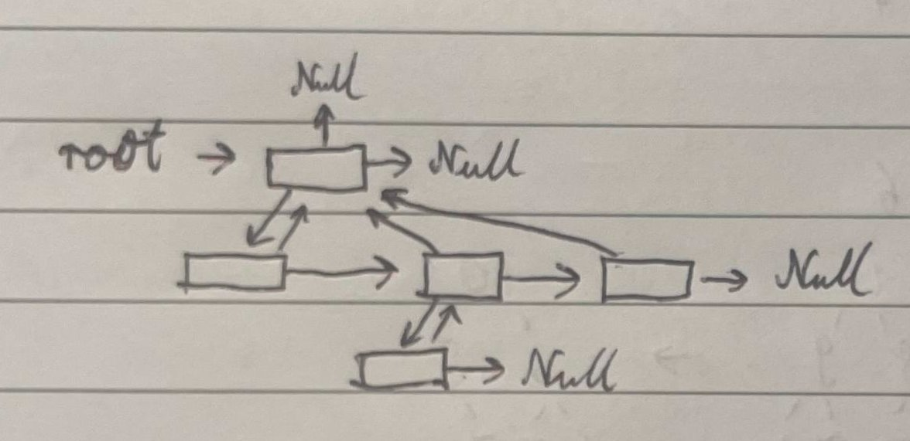

## Section 3: Pseudocode of operations:

Replace this text with an appropriate Pseudo Code.

Pseudocode of each of the methods used

FindParent(x) : returns the parent of node x

return x.parent;

FindChild(x): returns the children of a node x

children_list = [];

current = x.left_child;

while (current != null):

children_list.append(current);

current = current.right_sibling;

return children_list;

FindSiblings(x): returns the siblings of a node x

siblings_list = FindChild(x.parent);

siblings_list.remove(x);

return siblings_list;

## Section 4: Demo using example

The demos for the operations will be done on the following data set, which represents the first two moves for a game of noughts and crosses:

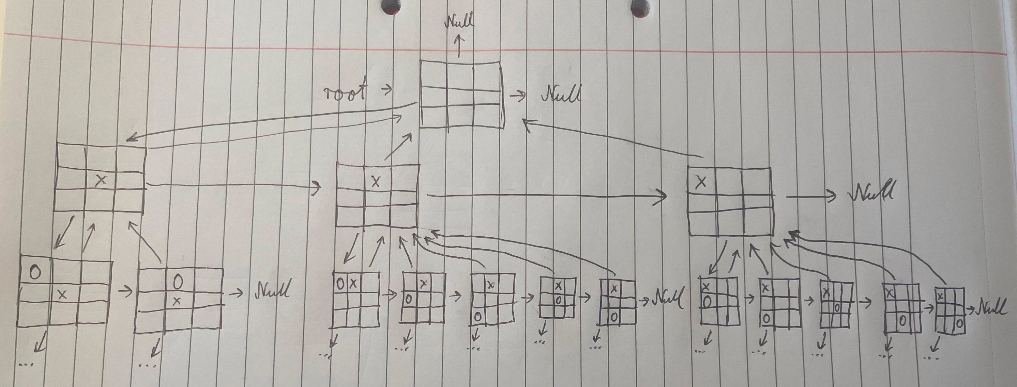

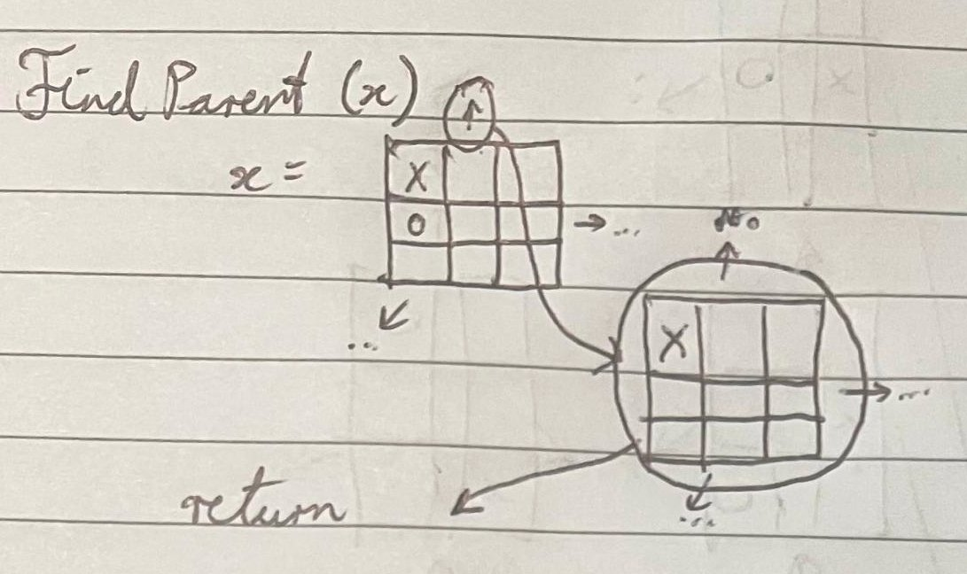FindParent(x)

The parent pointer of the input node is returned.

FindChild(x)

To get the children of a node, it first gets the left_child of the node, then loops through all of the child’s right_siblings until it reaches null. All of the nodes traversed are recorded and returned.

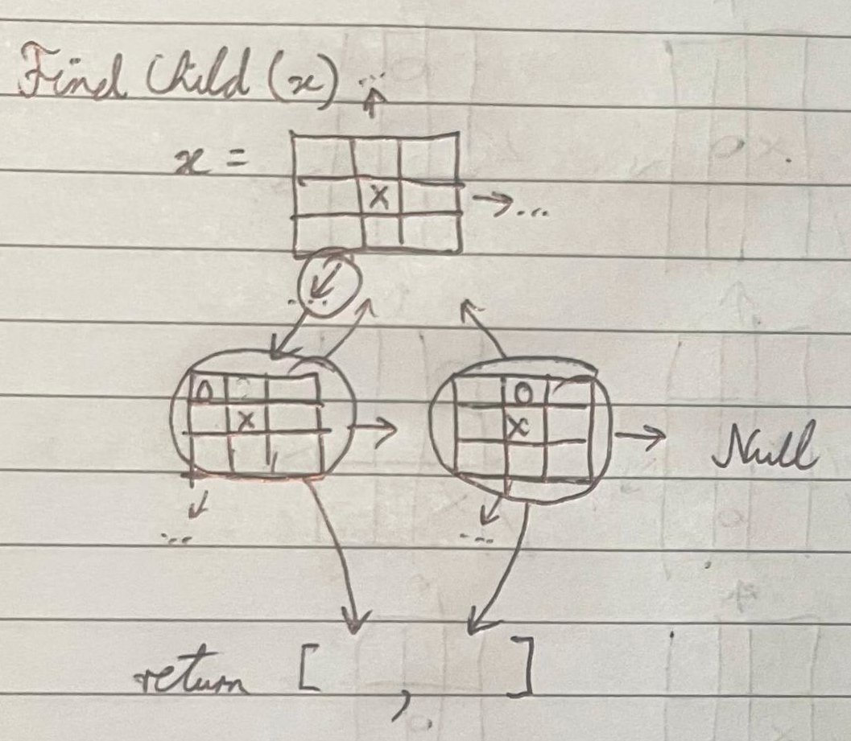

FindSibling(x)

This first calls FindChild on the parent node of the node input, to get all of the nodes. Then the node itself is removed from the list to get a list of sibling nodes.

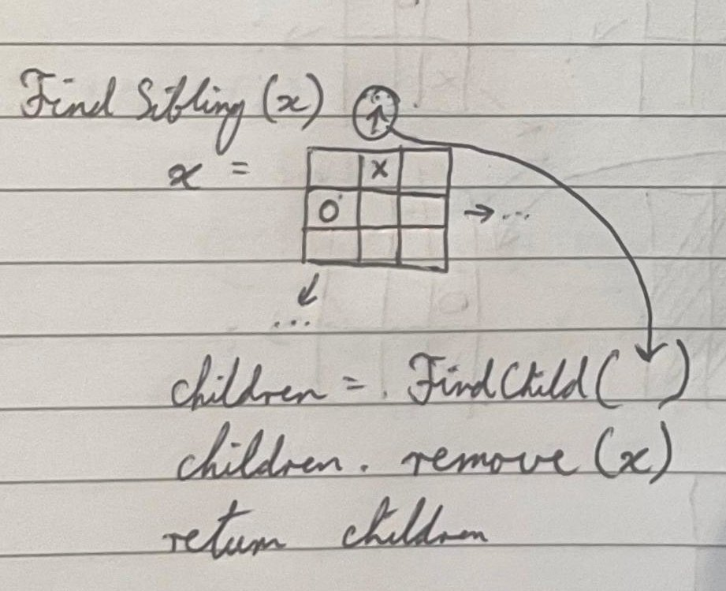

# Part 3:

## Section 5: Description of methods used

main() - runs the UI for the application.

initialise_sample_heap() - creates a sample heap.

Heap.increase_array_size(new_array_size: int) – increases the heap size by the specified amount.

Heap.upheap(x: int) – up heaps the value at the index.

Heap.insert(x: int) – inserts the number into the heap.

Heap.find_parent(x: int) – returns the index of the parent of the given index of number.

Heap.find_child(x: int) – returns the index of the children of the given index of number.

Heap.delete_small() - deletes the smallest value from the heap.

Heap.pretty_print_heap() - prints the heap out graphically.

## Section 6: Test data Used

The following data is used as testing data for the code application. The heap is pre-populated upon starting the program.

Heap values in the array = [0, 82, 72, 40, 56, 61, 22, 30, 20, 51, 60, 2, 5, 19, 10, 13, 3, 15, 8, 11, 4, 16]

## Section 7: Sample execution

Replace this text with Sample execution screenshots.

Include screen shots of your application running on the test data described above. Demonstrate via screenshots, how each option on the menu runs. Ensure that screenshots are neat, readable and cropped to correct size.

## Section 8: Copy of Code

class Heap:

# values is used as an array

values: list = [0]

# last_index is the position where the last value is

last_index: int = 0

# increases the values size to the new array size

def increase_array_size(self, new_array_size: int) -> None:

for index in range(len(self.values), new_array_size):

self.values.append(0)

# up heaps value in given index

def up_heap(self, x: int):

parent_index: int = self.find_parent(x)

current_index: int = x

while parent_index != 0 and self.values[current_index] > self.values[parent_index]:

# swapping values

self.values[parent_index], self.values[current_index] = (

self.values[current_index],

self.values[parent_index],

)

current_index = parent_index

parent_index = self.find_parent(current_index)

# increases array size then inserts the new value, and up heaps

def insert(self, x: int) -> None:

self.last_index += 1

if self.last_index >= len(self.values):

self.increase_array_size((len(self.values) * 2))

self.values[self.last_index] = x

self.up_heap(self.last_index)

# parent at floor division 2 of index given

def find_parent(self, x: int) -> int:

return x // 2

# returns the left and right child indexes

def find_child(self, x: int) -> tuple:

return (x * 2, (x * 2) + 1)

# finds smallest value, swaps with last value and up heaps

def delete_small(self) -> None:

starting_index: int = self.find_parent(self.last_index) + 1

smallest_value: int = self.values[starting_index]

smallest_value_index: int = starting_index

# loops through all leaf nodes

for index in range(starting_index + 1, self.last_index + 1):

if self.values[index] < smallest_value:

smallest_value = self.values[index]

smallest_value_index = index

# swapping values

self.values[smallest_value_index], self.values[self.last_index] = (

self.values[self.last_index],

self.values[smallest_value_index],

)

# delete value

self.values[self.last_index] = 0

self.last_index -= 1

self.up_heap(smallest_value_index)

# prints the heap graphically

def pretty_print_heap(self) -> None:

print("INFO: The graphical print may break when there are many values in the heap, or the values are too big.")

print_lines_list: list = []

# keeps track of multiples of 2

current_multiple: int = 1

longest_number_length: int = 0

counter: int = 1

# organises values to print out

for index in range(1, self.last_index + 1):

if index == current_multiple:

print_lines_list.append([" ", str(self.values[index])])

current_multiple *= 2

counter = counter * 2 + 1

else:

# add to last line

print_lines_list[-1].append(" ")

print_lines_list[-1].append(self.values[index])

if longest_number_length < len(str(self.values[index])):

longest_number_length = len(str(self.values[index]))

counter //= 2

other_counter: int = len(print_lines_list)

for line in print_lines_list:

# prints out markers whether each node is a left or right child

if len(line) != 2:

left: bool = True

for index in range(len(line)):

if line[index] == " ":

if index == 0:

print(

" "

* (

counter * longest_number_length

- (2**other_counter)

),

end="",

)

else:

print(" " * (

counter * longest_number_length), end="")

else:

print(" " * (longest_number_length - 1), end="")

if left:

print("/", end="")

else:

print("\\", end="")

left = not left

print()

# prints out values

for index in range(len(line)):

if line[index] == " ":

if index == 0:

print(

" "

* (

counter * longest_number_length

- (2**other_counter)),

end="",

)

else:

print(" " * (

counter * longest_number_length), end="")

else:

print(" " * (

longest_number_length

- len(str(line[index]))), end="")

print(line[index], end="")

print()

counter //= 2

other_counter -= 1

def initialise_sample_heap() -> Heap:

heap: Heap = Heap()

heap.insert(30)

heap.insert(20)

heap.insert(5)

heap.insert(15)

heap.insert(16)

heap.insert(22)

heap.insert(10)

heap.insert(3)

heap.insert(8)

heap.insert(4)

heap.insert(2)

heap.insert(19)

heap.insert(51)

heap.insert(40)

heap.insert(13)

heap.insert(56)

heap.insert(60)

heap.insert(11)

heap.insert(72)

heap.insert(61)

heap.insert(82)

return heap

def main():

heap: Heap = initialise_sample_heap()

print("Heap printed as an array:")

print(heap.values[:heap.last_index + 1])

print("Heap printed graphically:")

heap.pretty_print_heap()

while True:

print()

print("1 - Insert Number")

print("2 - Find Parent of Index")

print("3 - Find Children of Index")

print("4 - Delete Smallest")

print("5 - Print Heap")

print("6 - Exit")

input_number: str = input("Select an number: ")

match input_number:

case "1":

number_in: str = input("Input number to insert: ")

if number_in.isdigit():

heap.insert(int(number_in))

print("Number inserted.")

else:

print("Not a number put in!")

case "2":

number_in: str = input("Input index to get parent: ")

if number_in.isdigit():

print(f"Parent index: {heap.find_parent(int(number_in))}")

else:

print("Not a number put in!")

case "3":

number_in: str = input("Input index to get children: ")

if number_in.isdigit():

print(f"Children indexes: {heap.find_child(int(number_in))}")

else:

print("Not a number put in!")

case "4":

heap.delete_small()

print("Smallest deleted.")

case "5":

print("Heap printed as an array:")

print(heap.values[:heap.last_index + 1])

print("Heap printed graphically:")

heap.pretty_print_heap()

case "6":

break

case _:

print("Input numbers 1 - 5!")

if __name__ == "__main__":

main()

## Section 9: Conclusion

# References

Include Acknowledge Describe Evidence Form (if appropriate)